USB3.0/2.0 MUX DEMUX Design Document

Version: 0.1
Status: Draft
Author: mvdw1

Summary and Goal

The goal of this project is to create a USB3.0/2.0 Multiplexer-Demultiplexer (muxdemux) with bidirectional support. While similar devices exist in the form of KVM USB switches, most lack a programmable/serial interface or come with high costs.

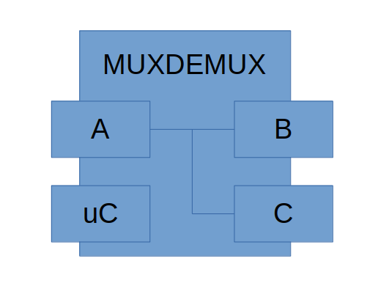
A block diagram is shown above. The uC (micro controller) handles serial / IO inputs, and allows switching connections between AB and AC.
Example Application

This tool finds its application in scenarios such as the test automation of an embedded product with only one USB port. Many of these devices can be factory flashed using the USB port and also support USB functionality. In automatic testing, both need to be tested, without an operator being present to change the USB connection

In this case, the tool enables the multiplexing of the USB port of the embedded device between the programming tool and the USB drive. An automated test framework can utilize either the serial interface or the digital IO interface to control which USB connection is linked to the embedded device.
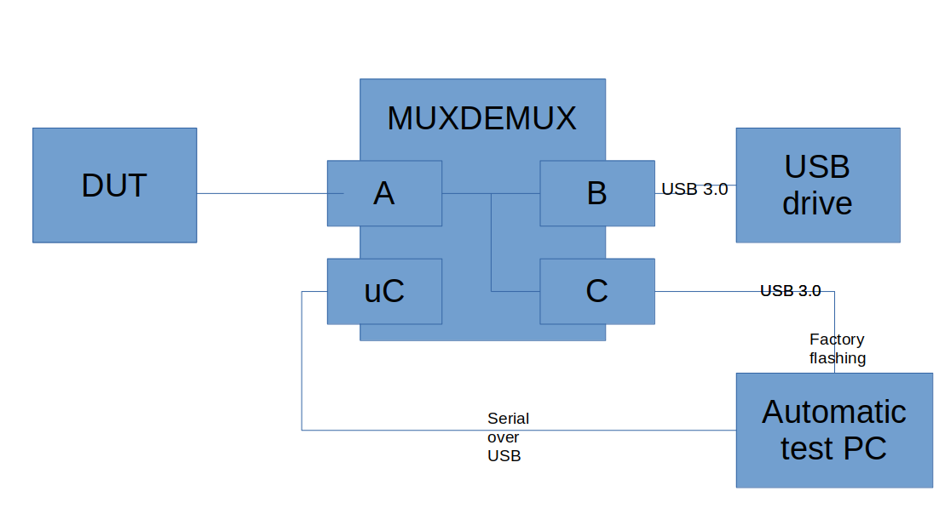
License:

This design is offered as is and follows the principles of open-source hardware (OSHWA). No guarantees are provided, and no claims can be asserted regarding the usage or performance of this project's design. If assurances regarding performance, safety, or any other aspect are essential, it is advisable to consider purchasing a commercial product rather than relying on this OSHWA project.

Design Summary and Notes

USB Signals and Multiplexing

The USB multiplexing functionality is achieved through the utilization of a TI HD3SS6126RUAR USB 3.0 + USB 2.0 Differential Switch 2:1/1:2 MUX/DEMUX. Detailed specifications for this component can be found at https://www.ti.com/lit/ds/symlink/hd3ss6126.pdf.

The recommended layout for the HD3SS6126RUAR involves a 4-layer PCB configuration. The top layer is dedicated to the USB 3.0 signals, with a secondary layer serving as the ground plane, a third layer designated as the power plane, and a fourth layer reserved for other signals. This layout is adhered to whenever possible, especially in the vicinity of the HD3SS6126RUAR.

For the USB 3.0 signals, differential pairs have been meticulously routed. To ensure compliance with the desired 90 ohm +/- 15% differential impedance and 50 ohm to ground, the following PCB stackup is employed:
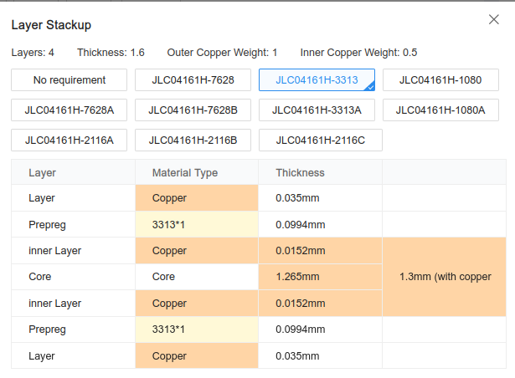
Source: JLCPCB

Using a trace spacing of 6mil, the expected impedance was calculated using a tool from JLCPCB:

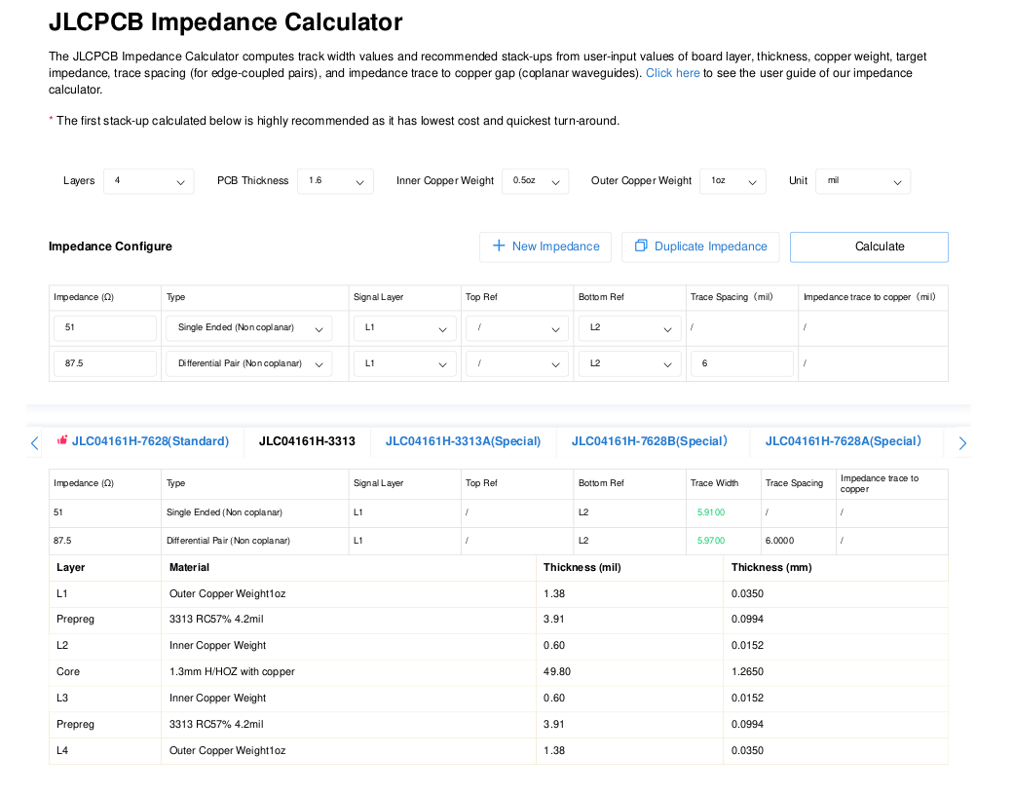
USB power
The micro controller board gets power from its USB port, ort from the 4 pin header using its 5V pin.

The muxable USB ports get their power from the device(s) attached to them. Two ways are provided to connect power between the 3 ports:
1 Using 2x Toshiba TLP3543A(TP1,F opto isolators to bidirectionally connect VUSB between Ports A – B and A - C. This allows the microcontroller to switch the VUSB connection only to the active port
2 Using a jumper on 2 headers to make a connection

When option 2 is used, the opto isolators can also be left unpopulated

Input, Control, and Status

Controlling the device is facilitated through a readily available micro controller board, with options including the Seeeduino XIAO or ESP32-C3 super mini, or any board with a similar footprint.

These micro controller boards are equipped with an onboard USB connector for programming and serial input. The serial input is designed to accept simple commands, enabling users to either switch off the mux/demux or toggle the USB inputs. In addition to the serial input, a physical button is incorporated for convenient manual switching, complemented by an IO input that allows external devices to control the muxdemux.

Device status is visually indicated through a series of LEDs.

Software

The device is supported by simple software developed using the Arduino IDE/framework. The code is available in this repository and is distributed under the GPLv3 license.

Testing

- No testing has been done yet. A previous version of the design (including a similar layout of USB3.0 / 2.0 signals) had some limited testing by attaching it to an embedded device and

Further Notes:

- Lead-free solder is recommended for use.
- As design tool, the free EasyEDA was used. Design files are exported in the format of EasyEDA.
- Additionally, PDF exports are also provided
- The design is ordered at JLCPCB. Other PCB manufacturers could also suffice, but may need alteration in the PCB to reach design/production guidelines and alterations for difference in stackup capabilities

